**`Joins Between Tables**

Thus far, our queries have only accessed one table at a time. Queries can access multiple tables at once, or access the same table in such a way that multiple rows of the table are being processed at the same time. A query that accesses multiple rows of the same or different tables at one time is called a *join* query.

**DEPT TABLE**

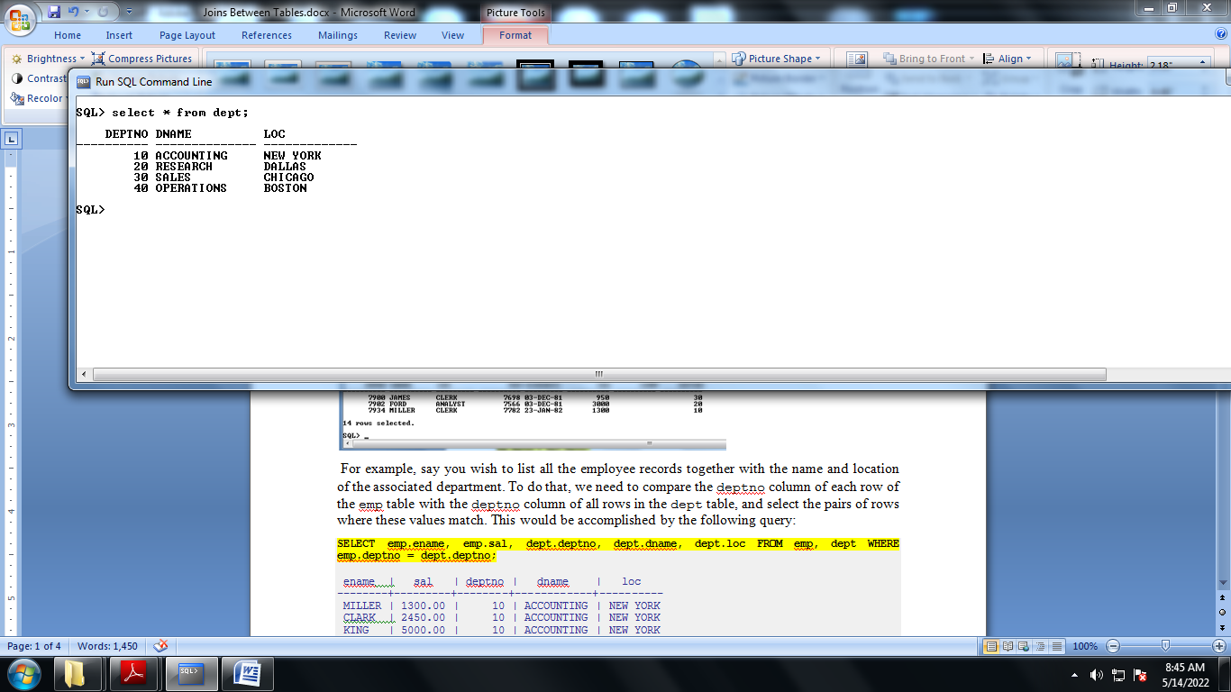

**EMP TABLE**

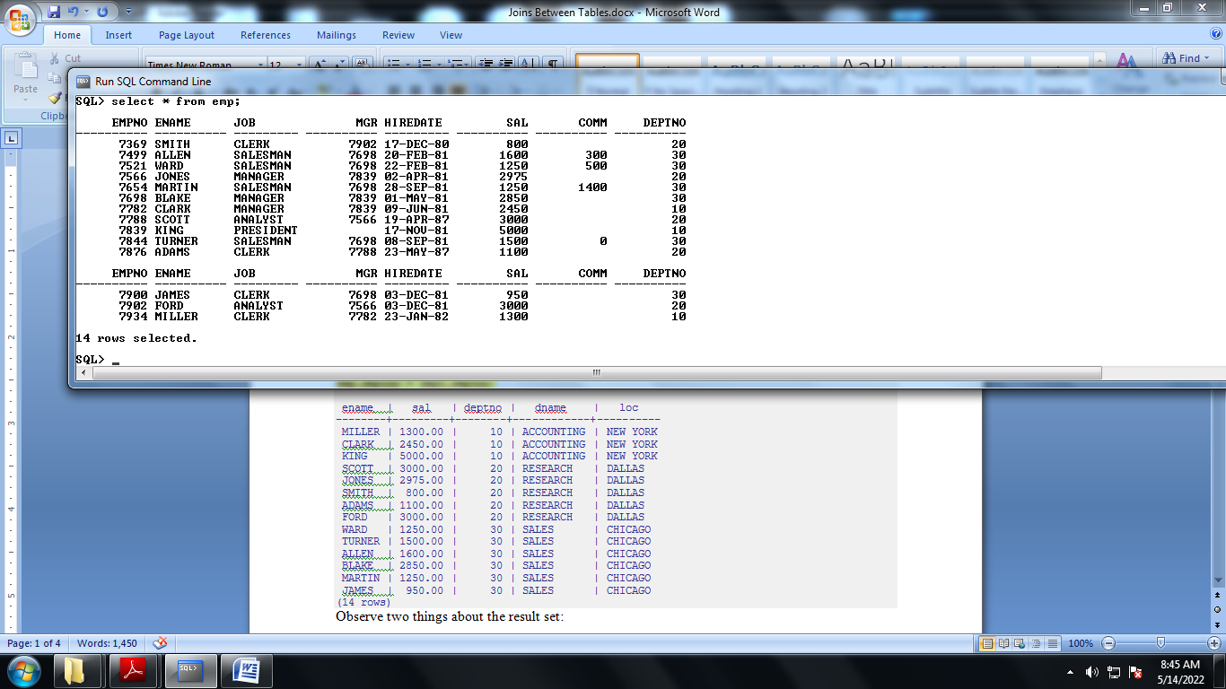

For example, say you wish to list all the employee records together with the name and location of the associated department. To do that, we need to compare the deptno column of each row of the emp table with the deptno column of all rows in the dept table, and select the pairs of rows where these values match. This would be accomplished by the following query:

**SELECT emp.ename, emp.sal, dept.deptno, dept.dname, dept.loc FROM emp, dept WHERE emp.deptno = dept.deptno;**

ename | sal | deptno | dname | loc

--------+---------+--------+------------+----------

MILLER | 1300.00 | 10 | ACCOUNTING | NEW YORK

CLARK | 2450.00 | 10 | ACCOUNTING | NEW YORK

KING | 5000.00 | 10 | ACCOUNTING | NEW YORK

SCOTT | 3000.00 | 20 | RESEARCH | DALLAS

JONES | 2975.00 | 20 | RESEARCH | DALLAS

SMITH | 800.00 | 20 | RESEARCH | DALLAS

ADAMS | 1100.00 | 20 | RESEARCH | DALLAS

FORD | 3000.00 | 20 | RESEARCH | DALLAS

WARD | 1250.00 | 30 | SALES | CHICAGO

TURNER | 1500.00 | 30 | SALES | CHICAGO

ALLEN | 1600.00 | 30 | SALES | CHICAGO

BLAKE | 2850.00 | 30 | SALES | CHICAGO

MARTIN | 1250.00 | 30 | SALES | CHICAGO

JAMES | 950.00 | 30 | SALES | CHICAGO

(14 rows)

Observe two things about the result set:

|  |  |
| --- | --- |
|  | There is no result row for department 40. This is because there is no matching entry in the emp table for department 40, so the join ignores the unmatched rows in the dept table.  Shortly we will see how this can be fixed. |
|  | It is more desirable to list the output columns qualified by table name rather than using * or leaving out the qualification as follows: |

SELECT ename, sal, dept.deptno, dname, loc FROM emp, dept WHERE emp.deptno = dept.deptno;

Since all the columns had different names (except for deptno which therefore must be qualified), the parser automatically found out which table they belong to, but it is good style to fully qualify column names in join queries:

Join queries of the kind seen thus far can also be written in this alternative form:

SELECT emp.ename, emp.sal, dept.deptno, dept.dname, dept.loc FROM emp INNER JOIN dept ON emp.deptno = dept.deptno;

This syntax is not as commonly used as the one above, but we show it here to help you understand the following topics.

You will notice that in all the above results for joins no employees were returned that belonged to department 40 and as a consequence, the record for department 40 never appears. Now we will figure out how we can get the department 40 record in the results despite the fact that there are no matching employees. What we want the query to do is to scan the dept table and for each row to find the matching emp row. If no matching row is found we want some “empty” values to be substituted for the emp table’s columns. This kind of query is called an *outer join*. (The joins we have seen so far are *inner joins*.) The command looks like this:

SELECT emp.ename, emp.sal, dept.deptno, dept.dname, dept.loc FROM dept LEFT OUTER JOIN emp ON emp.deptno = dept.deptno;

ename | sal | deptno | dname | loc

--------+---------+--------+------------+----------

MILLER | 1300.00 | 10 | ACCOUNTING | NEW YORK

CLARK | 2450.00 | 10 | ACCOUNTING | NEW YORK

KING | 5000.00 | 10 | ACCOUNTING | NEW YORK

SCOTT | 3000.00 | 20 | RESEARCH | DALLAS

JONES | 2975.00 | 20 | RESEARCH | DALLAS

SMITH | 800.00 | 20 | RESEARCH | DALLAS

ADAMS | 1100.00 | 20 | RESEARCH | DALLAS

FORD | 3000.00 | 20 | RESEARCH | DALLAS

WARD | 1250.00 | 30 | SALES | CHICAGO

TURNER | 1500.00 | 30 | SALES | CHICAGO

ALLEN | 1600.00 | 30 | SALES | CHICAGO

BLAKE | 2850.00 | 30 | SALES | CHICAGO

MARTIN | 1250.00 | 30 | SALES | CHICAGO

JAMES | 950.00 | 30 | SALES | CHICAGO

| | 40 | OPERATIONS | BOSTON

(15 rows)

This query is called a *left outer join* because the table mentioned on the left of the join operator will have each of its rows in the output at least once, whereas the table on the right will only have those rows output that match some row of the left table. When a left-table row is selected for which there is no right-table match, empty (NULL) values are substituted for the right-table columns.

An alternative syntax for an outer join is to use the outer join operator, “(+)”, in the join condition within the WHERE clause. The outer join operator is placed after the column name of the table for which null values should be substituted for unmatched rows. So for all the rows in the dept table that have no matching rows in the emp table, Postgres Plus Advanced Server returns null for any select list expressions containing columns of emp. Hence the above example could be rewritten as:

SELECT emp.ename, emp.sal, dept.deptno, dept.dname, dept.loc FROM dept, emp WHERE emp.deptno(+) = dept.deptno;

ename | sal | deptno | dname | loc

--------+---------+--------+------------+----------

MILLER | 1300.00 | 10 | ACCOUNTING | NEW YORK

CLARK | 2450.00 | 10 | ACCOUNTING | NEW YORK

KING | 5000.00 | 10 | ACCOUNTING | NEW YORK

SCOTT | 3000.00 | 20 | RESEARCH | DALLAS

JONES | 2975.00 | 20 | RESEARCH | DALLAS

SMITH | 800.00 | 20 | RESEARCH | DALLAS

ADAMS | 1100.00 | 20 | RESEARCH | DALLAS

FORD | 3000.00 | 20 | RESEARCH | DALLAS

WARD | 1250.00 | 30 | SALES | CHICAGO

TURNER | 1500.00 | 30 | SALES | CHICAGO

ALLEN | 1600.00 | 30 | SALES | CHICAGO

BLAKE | 2850.00 | 30 | SALES | CHICAGO

MARTIN | 1250.00 | 30 | SALES | CHICAGO

JAMES | 950.00 | 30 | SALES | CHICAGO

| | 40 | OPERATIONS | BOSTON

(15 rows)

We can also join a table against itself. This is called a *self join*. As an example, suppose we wish to find the name of each employee along with the name of that employee’s manager. So we need to compare the mgr column of each emp row to the empno column of all other emp rows.

SELECT e1.ename || ' works for ' || e2.ename AS "Employees and their Managers" FROM emp e1, emp e2 WHERE e1.mgr = e2.empno;

Employees and their Managers

------------------------------

FORD works for JONES

SCOTT works for JONES

WARD works for BLAKE

TURNER works for BLAKE

MARTIN works for BLAKE

JAMES works for BLAKE

ALLEN works for BLAKE

MILLER works for CLARK

ADAMS works for SCOTT

CLARK works for KING

BLAKE works for KING

JONES works for KING

SMITH works for FORD

(13 rows)

Here, the emp table has been re-labeled as e1 to represent the employee row in the select list and in the join condition, and also as e2 to represent the matching employee row acting as manager in the select list and in the join condition. These kinds of aliases can be used in other queries to save some typing, for example:

SELECT e.ename, e.mgr, d.deptno, d.dname, d.loc FROM emp e, dept d WHERE e.deptno = d.deptno;

ename | mgr | deptno | dname | loc

--------+------+--------+------------+----------

MILLER | 7782 | 10 | ACCOUNTING | NEW YORK

CLARK | 7839 | 10 | ACCOUNTING | NEW YORK

KING | | 10 | ACCOUNTING | NEW YORK

SCOTT | 7566 | 20 | RESEARCH | DALLAS

JONES | 7839 | 20 | RESEARCH | DALLAS

SMITH | 7902 | 20 | RESEARCH | DALLAS

ADAMS | 7788 | 20 | RESEARCH | DALLAS

FORD | 7566 | 20 | RESEARCH | DALLAS

WARD | 7698 | 30 | SALES | CHICAGO

TURNER | 7698 | 30 | SALES | CHICAGO

ALLEN | 7698 | 30 | SALES | CHICAGO

BLAKE | 7839 | 30 | SALES | CHICAGO

MARTIN | 7698 | 30 | SALES | CHICAGO

JAMES | 7698 | 30 | SALES | CHICAGO

(14 rows)

This style of abbreviating will be encountered quite frequently.